2019
Acceleration Transformative Research for Medical Innovation
Set-up Scheme【ACT-MS】
APPLICATION

Entry Theme (Choose either): 1. Drug 2. Medical Tec.

Project Title
XXXXXXXXXXXXXXXXXXXXXXXX

Leader of Project
Name NNNNN FFFFFF
Affiliation ZZZZZZ University / ZZZZZZ Institute
Department Department of YYYYYY
Position title ZZZZZZZZZZ

(When creating the document please delete the notes and example (in italics))

Basic Concept（Please describe the requisite content as a supplement to the project outline)
- The R&D phase that is the target for the R&D
・Please indicate with an arrow the R&D process in either diagram that is nearest to the R&D you are targeting. Delete the other diagram. Note that you should contact the secretariat in the event that the periods for the start of your R&D differ significantly from the scope targeted by ACT-MS.

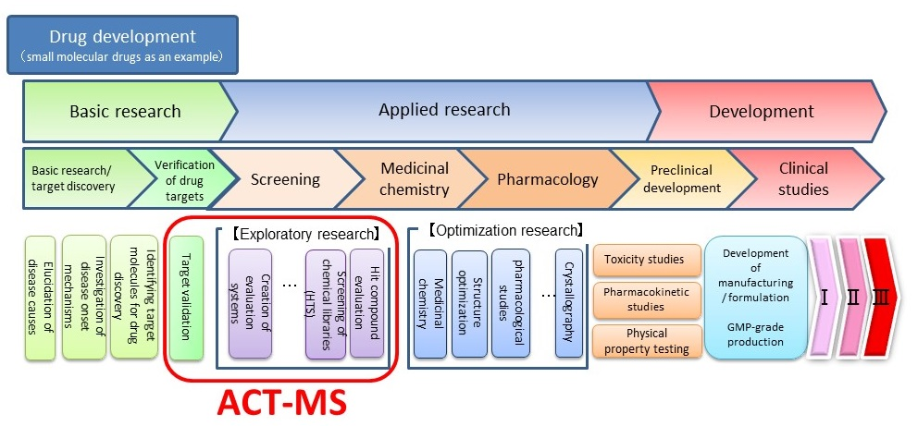

Completion
Start

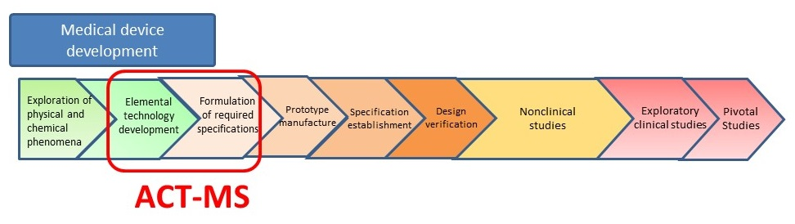
Completion
Start

2. Purpose
Indicate the purpose of your proposal and clarify the targets of your research.

3. Background
Indicate the current situation, the problems, the social needs, and the necessity of your research.

4. Seeds and Originality
Indicate the seeds of your research, clarify the originality and uniqueness.

5. Research Body
Describe the specific research plan and method that will achieve your purpose.

6. Outcome
Describe the expected emerging technology and products based on the results of your research.

7. Competiveness
List current technology, products and services. Clarify the advantage of your research.

8. Social Impact
Describe the expected contribution to society and the prospects for innovation provided by your research.

9. Breakthrough Point
Indicate the most important and difficult challenges.

10. Organization
List the leader and main co-researchers, including their names, affiliate institution, department, position, current profession, and responsibilities in the research.

11. Publication List
List up to five peer-reviewed articles published in English in reverse chronological order (most recent first) and specify the most relevant one(s) with an asterisk(s)(*).
1.
*2.
3.
4.
5.

12. Explanation of technical terms etc.

Technical term | Explanation
・Please provide a simple commentary on the professional jargon, specialist terms, abbreviations and other technical terms used in this proposal, which you feel are requisite for a complete understanding of the proposal including the research.

