2020
Acceleration Transformative Research for Medical Innovation
Set-up Scheme【ACT-MS】
APPLICATION

Entry Theme (Choose either): 1. Drug 2. Medical Tec.

Project Title
XXXXXXXXXXXXXXXXXXXXXXXX

Leader of Project
Name NNNNN FFFFFF
Institution ZZZZZZ University / ZZZZZZ Institute
Department Department of YYYYYY
Position title ZZZZZZZZZZ

(When creating the document please delete the notes and example (in italics))

1. The R&D phase that is the target for the R&D
・Please indicate with an arrow the R&D process in either Drug development or Medical device development diagram that is nearest to the R&D you are targeting. Delete the other diagram.
Note that you should contact the secretariat in the event that the periods for the start of your R&D differ significantly from the scope targeted by ACT-MS.

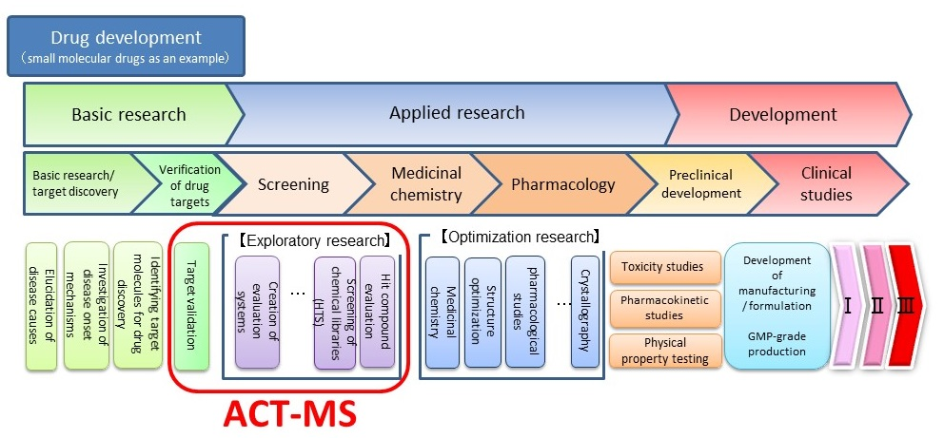

Start
Completion

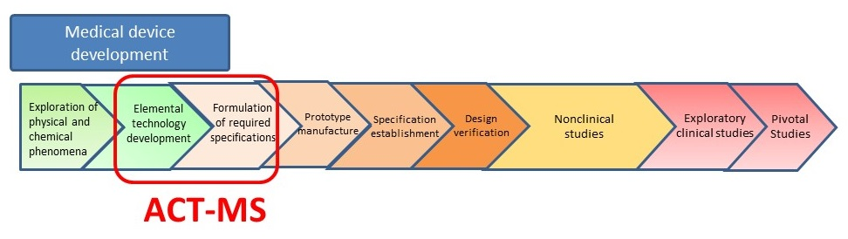
Completion
Start

* Please limit this “2. Abstract, 3. Keywords and 4. Publication list” form to two (2) pages include figures and tables.

2. Abstract(600 words maximum)
Outline your research proposal include following items in 600 words or less.
Describe the purpose, originality and uniqueness of seed, specific plan and method, anticipated results and the outcome.

3. Keywords (10 items maximum)
List as many as 10 terms that most likely represent the essence of the proposed research.
1. AAAAAAAAAAAA 2. BBBBBBBBBBBB 3. CCCCCCCCCCCC 4. DDDDDDDDDDDD
5. EEEEEEEEEEEE 6. FFFFFFFFFFFF 7. GGGGGGGGGGGG 8. HHHHHHHHHHHH
9. IIIIIIIIIIII 10. JJJJJJJJJJJJ

4. Publication List (5 items maximum)
List up to five peer-reviewed articles published in English in reverse chronological order (most recent first) and specify the most relevant one(s) with an asterisk(s)(*).
1.
*2.
3.
4.
5.

5. List of co-Principal Investigators

Name | Institution | Department | Position title
Example:  Taro Yamada | Japan Agency for Medical Research and Development | Department of Industrial Academic Collaboration | Chief R&D officer

